Inspection - Results

# Table

The following table shows the final scores we decided to assign for each heuristic. As already mentioned, the scoring scale is set from 0 to 4 (the specific meaning of each value can be found above); anyway, the reason for which we assigned each score is given in detail in the next section.



Table 1: Agreed scores of the heuristics

# Scores explanation

## H1 – Visibility of system status

We noticed that, in general, bread crumps have been implemented (statically) on the website to let users know about where they are.

However, these bread crumps have 2 problems:

* They always start with “Main/...” making the information about the visibility of system status redundant, since every page derives from the root page “Main” (See Figure 1).
* Bread crumps reflect URLs instead of the path followed by the user to reach a specific page; this could cause confusion inside users. An example is outlined by Figure 2: “Cost of living” page, whose bread crump is “Main/Applicants/Cost of living”, is reachable from a different path: How it works -> Eligibility (or Financing, or Academic credit) -> Cost of living.
* Few pages are totally devoid of bread crumps.

Figure 2: No matching between path and bread crump

Bread crump:

Main / Applicants / Cost of living

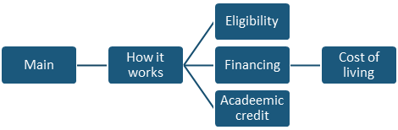

Figure 1: "Main" is redundant



## H2 – Match between system and the real world

In general, elements have been made intuitive as much as possible; in particular, we appreciated the choice of icons on the entire website and the “calendar style” lists of dates in many pages (such as the one on “Program Fees” page).

## H3 – User control and freedom

In the only page containing forms to fill (“Apply now” page), we noticed that once reached the phase where the user can book an interview with an Admission Consultants, there’s neither way to modify the personal information previously inserted nor to go back to previous phase of application process to do it.

For example, if a user realises to have inserted wrong data into personal information’s fields, he/she must restart the entire application process from the begin.

## H4 – Consistency and standards

In general, this heuristic is well satisfied. The only flaw is the bug shown in Figure 3: in some pages (such as “Application Process”, “Summer Internship”, “University / College students”, “Our team” and “Cost of living” pages) even if the “previous” button can be clicked, it is shown in grey, intuitively meaning that it can’t be clicked at that moment.

Figure 3: the grey button can be clicked

## H5 – Error prevention

Into the “Apply now” page’s form, fields are well-handled since their correctness is checked during user insertion of data.

However, this doesn’t happen when a user decides to request information by clicking on the “Contact us” button (present in almost every page) or to receive news about internship programs by filling the “Subscribe” filed on the bottom of every page: here the check is done only after the user clicks the submit button.

## H6 – Recognition rather than recall

On the entire website, this principle has been always applied when possible: wherever the user needs to choose between 2 or more elements, the website is provided with a list containing all the possible choices; in this way the user has just to click on his/her preferred choice instead of writing its name in a blank field.

An example can be seen in “Apply now” page: “Country code”, “Nationality”, “Country of residence”, “Career field” and “Destination” fields can be filled with elements from a list.

## H7 – Flexibility and efficiency of use

In general, the website is not so difficult to use; The presence of various landmarks in almost every page surely gives a great contribution to this. However, “Apply now” page is nearly devoid of landmarks (it only has the one linked to home page), bringing this page in a lower level than the others from the point of view of efficiency of use.

Moreover, the website supports only 1 single language (English); this could make the website not accessible to some kind of user.

## H8 – Aesthetic and minimalist design

We found the entire website well-done from this point of view.

## H9 – Help users recognize, diagnose and recover from errors

This principle has been taken into account, since “Apply now” page and “Contact us” pop-up help users to prevent errors while compiling fields by showing (in red) which field has been filled wrongly.

However, there are 2 problems on other pages:

* If a user inserts an invalid email in the field on the “Subscribe” section on the bottom of every page, the system shows the generic error “One or more fields have an error. Please check and try again”, saying “One or more” even if the filed to fill is only one (this problem have been considered minimally, since it isn’t a serious problem at all).
* Few links in some pages (such as the button “Learn more” referred to “IT & computer science internship in Italy” on the bottom of “Career Field – IT and Computer Science internship” page) bring users to an “Error 404” page like the one shown in Figure 4 (that is, some links bring to a not existing page).

We remark that we obviously considered the second problem much more than the first one for the evaluation of this heuristic.

Figure 4: “Learn more” button is linked to a not existing page (“Error 404” page)

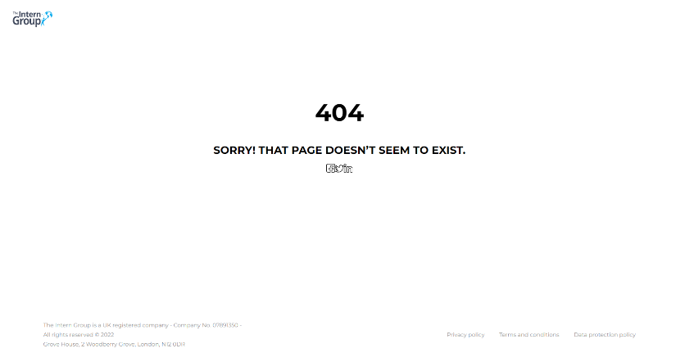

## H10 – Help and documentation

The website has lot of page and lot of information, but there isn’t any type of guide/help page to help users to orient themselves while navigating. This fact can be a great problem (especially for users that are impractical on using websites): in fact, a user who is searching for a specific information on the website could get nervous after spending lot of time navigating among pages without finding what he/she is searching for and, eventually, he/she could also give up and choose another website to retrieve that information. Some type of “user-guide” page would help to avoid situations like the one just described.

## C1 – Information overload

Some pages (such as home page and “Career field – IT & Computer Science internship” page) contain too much information, making a single page too dispersive.

Moreover, these data are often unnecessarily duplicated: the same information can be found in many pages of the website: for example, as shown in Figure 5, home page and “Career field – IT & Computer Science internship” page both contain exactly the same texts, boxes and links about the provided programs.

Figure 5: Identical content on 2 different pages of the websites

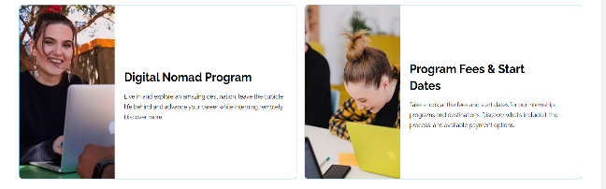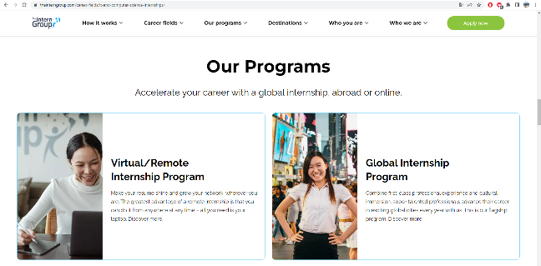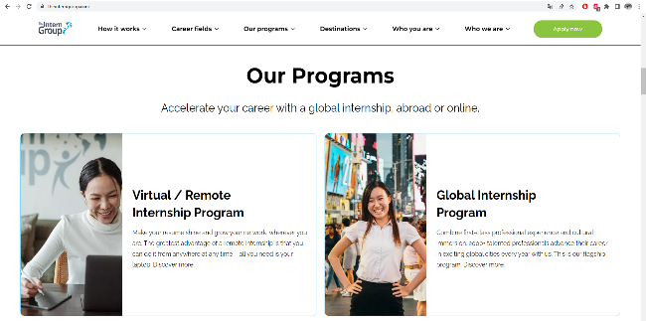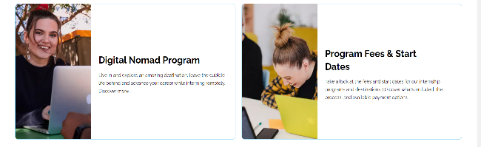

## C2 – Consistency of Page Content Structure

In our opinion, on the entire website all the pages belonging to a certain category have the same types of elements organized in the same way. For example, all the “Career fields” pages are consistent and coherently organized from this point of view.

## C3 – Content organization (Hierarchy)

Despite that almost all the pages have a good overall content organization, there are few pages whose Content order could be better implemented.

For example, in the home page and in “Career fields – IT & Computer Science internship” page, Sections which contains leading information (such as “How it works” section of the home page, which, empirically, many people would look for) should have placed before the ones containing secondary information (such as “Partner universities” section of the home page, which only few people would be interested in).

## P1 – Text lay out

In general, this principle has been well satisfied in the entire website.

The only tiny remark we would be that on few pages there are quite long texts devoid of any type of text-formatting (bold, italic, etc.) which could bore users, but this is not a real problem, so we didn’t consider it for the evaluation.

## P2 – Interaction placeholders-semiotics

In general, the interactive elements are totally intuitive, but we noticed that “Apply now” page is reachable from many buttons with different labels, as exemplified in Figure 6; a single label for every button linked to “Apply now” page would create less confusion.

Figure 6: Many buttons which are all linked to “Apply now” page



In “University/College students” page:



In the home page:

## P3 – Spatial allocation

We didn’t notice anything wrong concerning this heuristic: “semantically related” elements are close, “semantically distant” elements are distant.

## P4 – Consistency of Page Spatial Structure

The spatial organization of elements is coherent and consistent in the entire website: for example all the “Career fields” pages (which, obviously, are all of the same type) have the same spatial organization.

## N1 – Group navigation

In general, this heuristic has been well satisfied; in particular, we appreciated the presence of “Next” and “Previous” buttons on many pages (such as “Application Process”, “Summer Internship”, “University / College students”, “Our team” and “Cost of living” pages).

However, there are 2 small problems:

* There are some lists of images whose only way to switch between them is to click on the small circles under the list (each representing one element of the list); an additional way to navigate among them would have been better. An example can be found on the home page (shown on Figure 7).
* In “Our team” page, when opening the drop-down menu which filters people based on their nationality, the last elements of the drop-down menu are hidden behind the profile image of the first person, and then they are unclickable (see figure 8).

Figure 8: drop-down menu hidden behind the image

Figure 7: Images of the home page with small circles as only way to switch

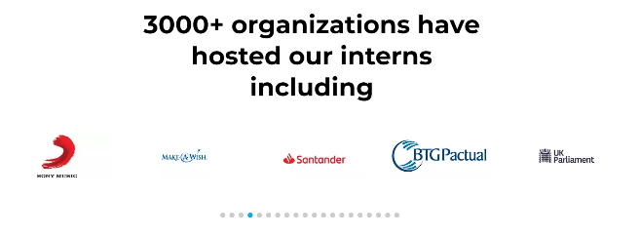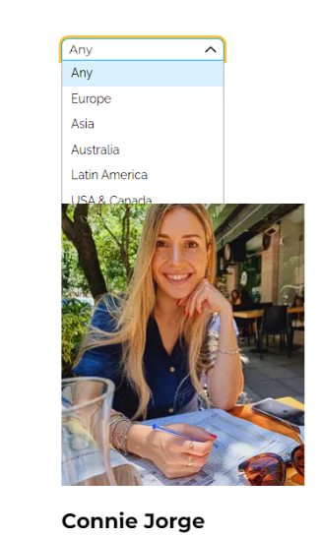

## N2 – Structural navigation

In general, the pages are rich of ways to navigate among components of a topic; the only weakness here, is that some pages (such as “Career field – IT & Computer Science internship” and “University / College students” pages) are devoid of lateral menu.

## N3 – Semantic navigation

There are some pages that aren’t directly indexed, meaning that they can’t be reached directly from the menu on the top of every page. The only way to reach them is through other specific pages (often, there is not even correlation between the 2 pages).

An example to understand better can be “Cost of living” page: this page isn’t indexed on the top menu and the only way to reach it is by going on “Eligibility”, “Academic credit” or “Financing” page (which, instead, are indexed on the top menu); once the user is on one of these pages, on the lateral menu the link “Cost of Living” appears (so, the top menu and the lateral one are not coherent).

## N4 – “Landmarks”

Landmarks are present (and well inserted) in every page but “Apply now” page: here the only landmark implemented is the one which allows to go back to home page; some additional landmark should have been included.

# Charts with aggregated scores

Nielsen’s heuristics Mile’s heuristics Average score



Figure 9: Chart of the aggregated scores of the heuristics & average score



Figure 10: Average scores of every single category of heuristic

# Discussion about the results

The average value of our evaluation is 2.86 (See Figure 9 to compare the scores among them); this highlights that the website is overall well done, even if it can be further improved.

In our analysis, the three categories in which all the heuristics are split have been considered in different percentages: we analysed 21 heuristics: 10 of them belong to “Presentation” category (47%), 8 to “Navigation” category (38%) and 4 to “Content” category (19%); Into our analysis, H6 have been counted both for “Presentation” and “Navigation” category.

As shown in the chart on Figure 10, the website excels from the aesthetics point of view, with an average score of heuristics belonging to “Presentation” category of 3.4: its intuitive elements (H2), its minimal design (H8) and its coherent disposition of elements in the pages (P3, P4) have been particularly appreciated and awarded with an awesome score.

The only part of the “Presentation” category which should be improved a little more is the one concerning errors prevention and recovers (H5, H9): here, in our opinion, a better care of details should be taken into account.

Also, from the “Navigation” point of view we have to recognize a good care: The great variety of landmarks available on almost every page (H7, N4) and the great number of ways to navigate among topics/pages (N1, N2) have let the average score of this category to be pretty high (2.63 exactly).

However, the website flaws a little on the precision about where the user is and where he/she has been before (mainly H1, but also N3): bread crumps are very important for users to orient themselves (especially in a website containing lot of information), so they can’t be neither overshadowed nor implemented superficially.

Finally, for what concerns “Content” heuristics, the average score of 2.25 can’t be defined low, considering that, as already mentioned, only 19% of heuristics contributed to this evaluation; here the main strength is the consistency of content into the pages (C2), while the worst weakness is the total absence of any type of help documentation/guide on the use of the website (H10), which, in some cases, it is not so trivial.